Aleksey Kramer

Data Science 450

Homework 1

**Write-up:**

I have download the file from the class web site and, removed the quality attribute and, through the trial and error, removing dimensions one by one, derived a set of two dimensions that result in 97.2% accuracy when classifying red and white wine: ***chlorides*** and ***total sulfur dioxide***. Based on the assignment, apparently, there is a way to achieve more than 99% accuracy, but the assignment required to have > 95% accuracy.

The screenshots are located on two pages just below.

**List of attributes to classify Red or White wine:**

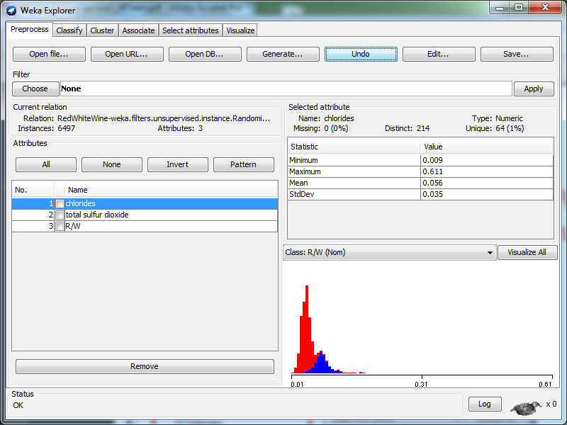

**Result of running classification based on the attributes selected:**

